**Final Project**

**By: Sean Flaherty**

Over the next four weeks you will be working on building your own API. The API can be anything you want, as long as it doesn't violate any school policies. Your API must meet the following, minimum requirements:

* Contain at least 5 entities

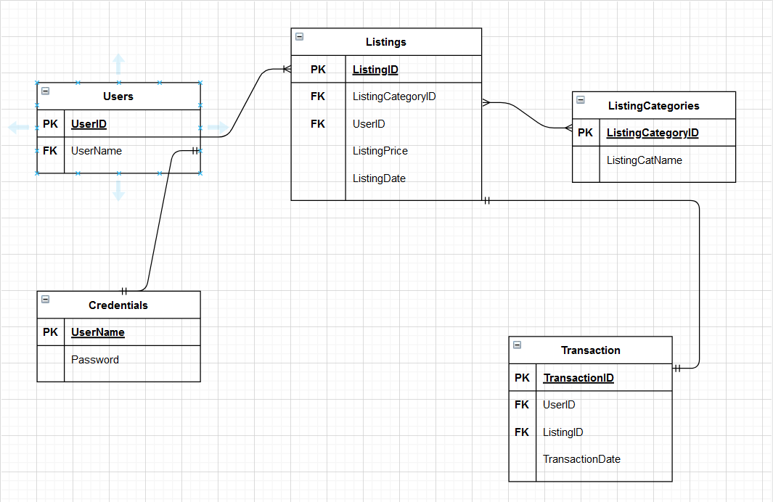

* Contain all CRUD operations

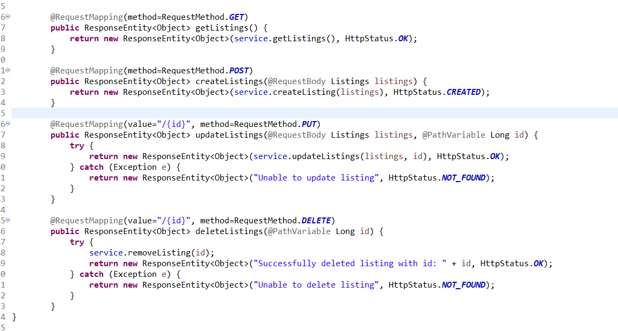

* Contain at least 1 one-to-many relationship

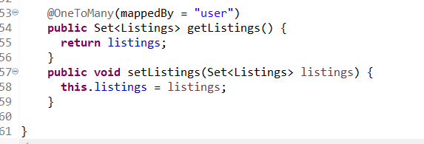

* Contain at least 1 many-to-many relationship

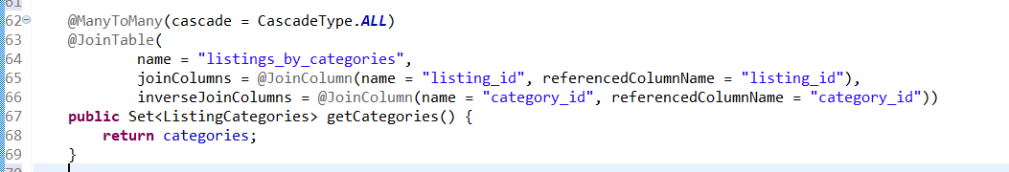

* Contain different application layers including at least controller, service, and repository

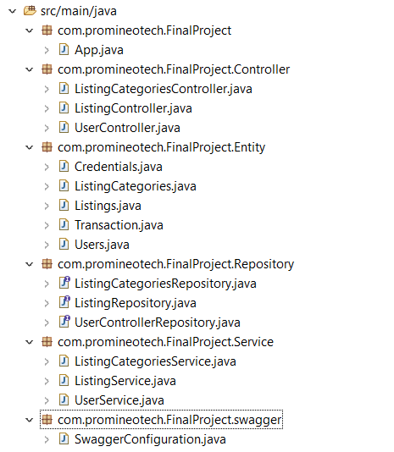

This week, please come up with an idea for your project and get it approved by your instructor as early as possible so you can start working on it. It is also recommended that you create a list of features that your API will have so you can work from that list. Below is an example.

Library API Example:  
- User can register and login

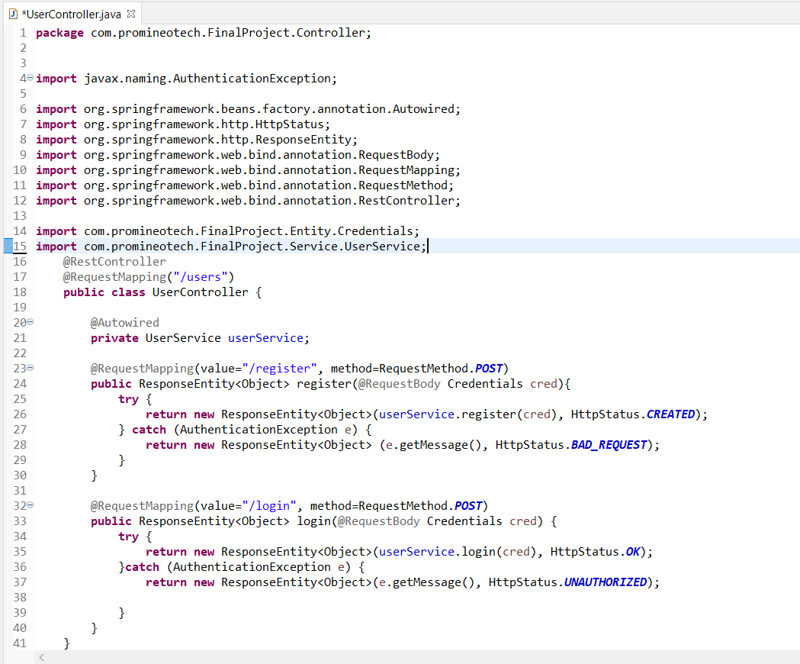  
  
- User can create listings

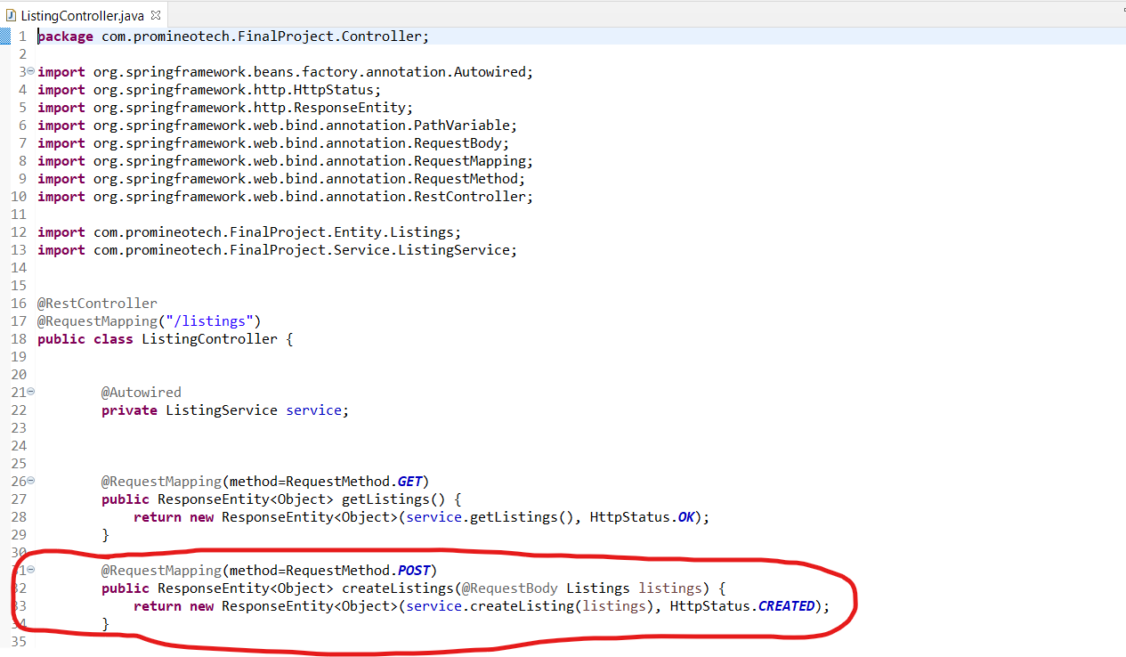

- User can delete listings

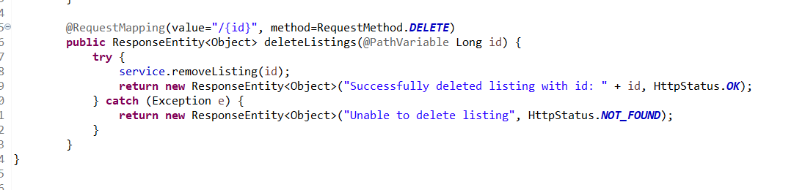

- User can update listings

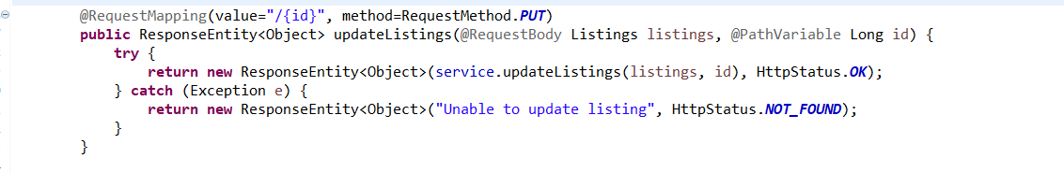

- User can browse all listings

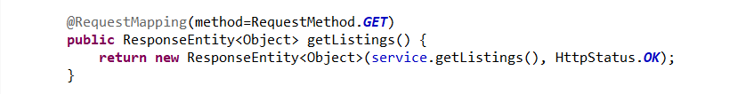

- User can browse by listing categories

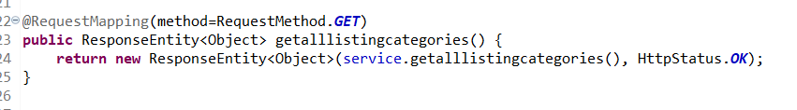  
  
- User can post a listing category.

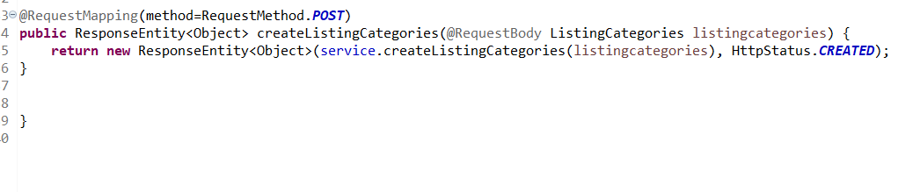

Post username:

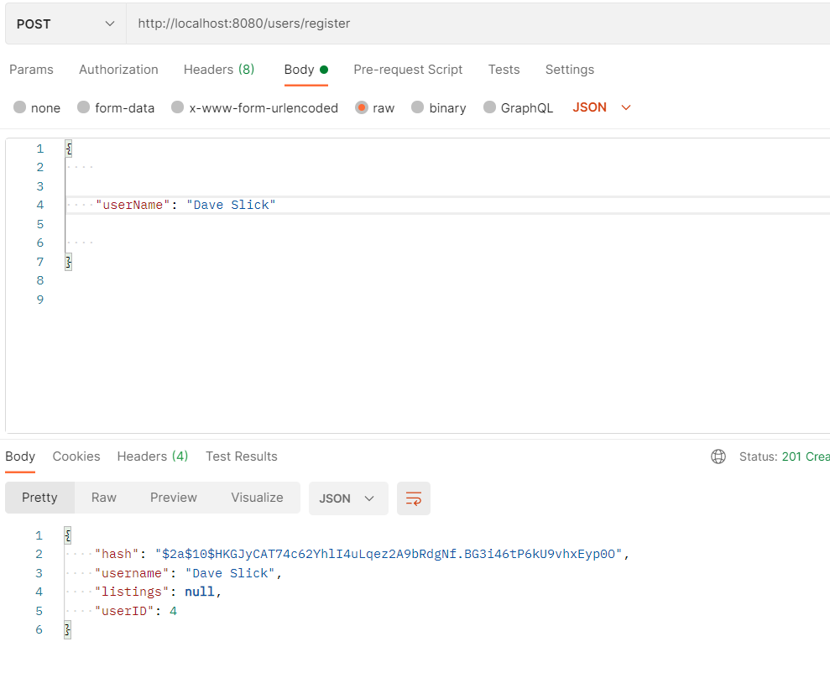

Post Listing:

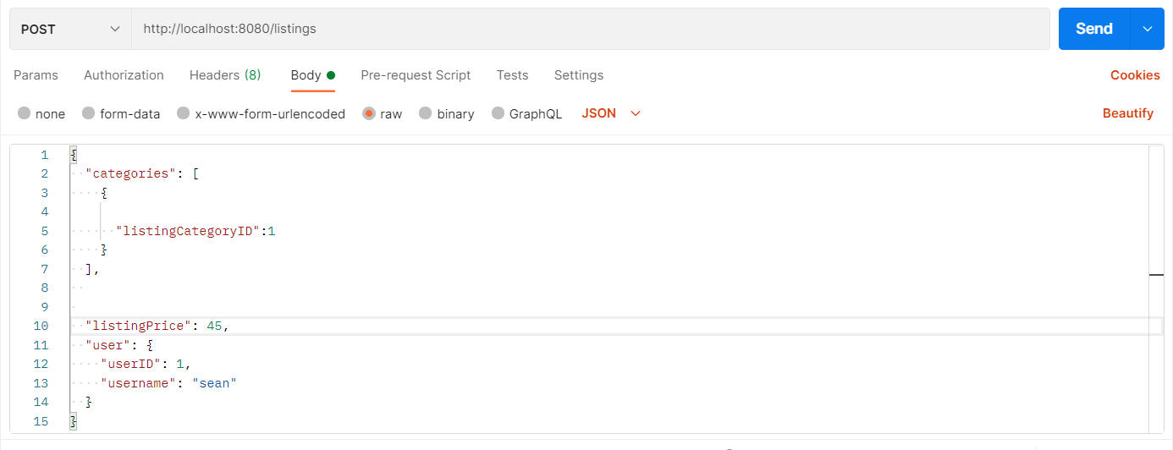

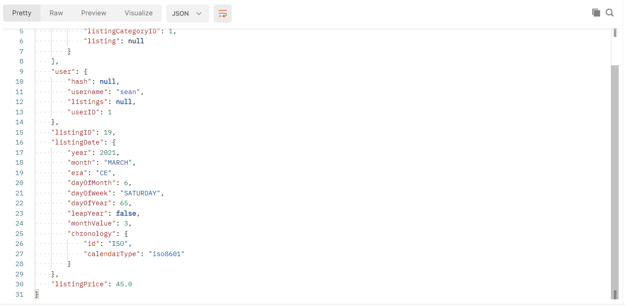

Read Listing

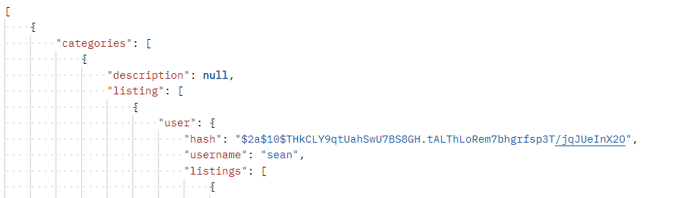

Put

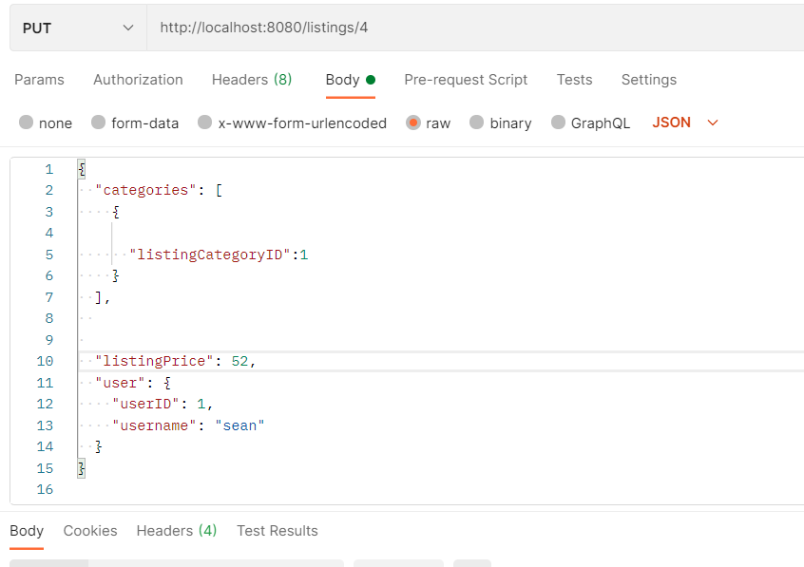

Delete

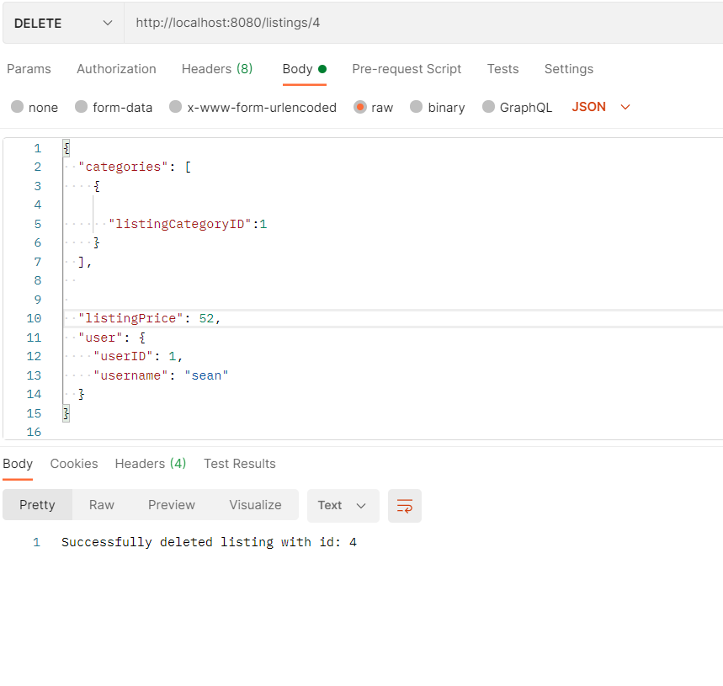

**Upload it to Github Link:**

[**https://github.com/sflaherty50/Spring-Boot-Final**](https://github.com/sflaherty50/Spring-Boot-Final)